Obesity App for Professionals and Families
Naming the Apps Competition

The University of Southampton’s Public Health team in partnership with Health Education England in Wessex and Thames Valley have been working with a collaboration of experts to develop two mobile apps aimed at supporting professionals to support families with children up to 15 years old to be healthier and prevent obesity. This partnership work is producing two behavioural change eTools (Apps) one aimed at professionals working with children and families and one for families.

The Professional’s App supports them to explore how they can help families to lead healthier lives. The App develops knowledge, understandings and skills of Professionals to overcome some of the common issues families may face when addressing health behaviours.

The Families App supports families to identify behavioural goals they can set to lead healthier lives. The App will be interactive where families will be able to monitor their progress against goals they have set and also explore top tips on how to overcome challenges and issues.

Both the Professionals and Families Apps can be linked where Professionals can then see how Families are progressing with their goals and identify opportunities to provide further support.

The home page of each App is provided below which outlines the design of the Professionals and Families App. The Apps are currently in development and we need your School’s help to come up with the perfect name for both the professionals and families apps.

If your School’s app name gets picked, both your school and the individual who came up with the name will be awarded a prize for everyone’s time, effort and creativity! Your school will receive a £500 voucher to go towards either books or sports equipment and the individual will receive a £30 voucher.

There are a few ’T's and C’s’:

- This competition will close on Friday 31st March 2017. The winner will be announced by the end of April 2017.
- To participate, the school must submit the App names for the competition.
- Schools can submit a maximum of three entries for this competition. These may be your top three names that are chosen from within your school.
- Individuals choosing the name must be under 15 years old and have the permission of your school to participate.
- The School will keep a record of the names of the individuals who came up with the submitted name for the Apps.
- The School and Individual understand that we will use the winning name as a title of our new apps, aimed at supporting professionals and families in helping prevent childhood obesity.
- The School and Individual give your permission to the Project Partners to use the app name (if chosen) on the App-store and across all public domain (e.g. internet, press, etc.).
- The School and Individual understand that the Project Partners reserve the right to choose a different app name if none of the submitted ones is deemed suitable for our purposes.

By putting an ‘x’ in this box below you agree to the terms and conditions

The School and Individual agree to the terms and conditions listed above.

The below images are the home screen for the two Apps which need to be named.

Professional’s App Families App

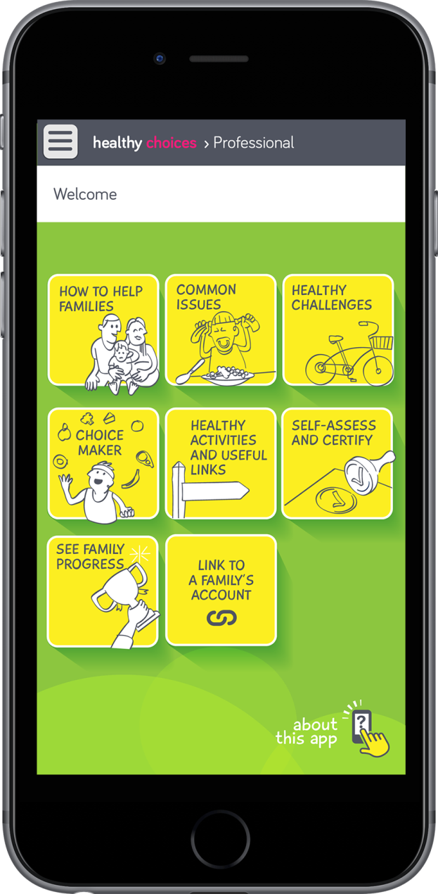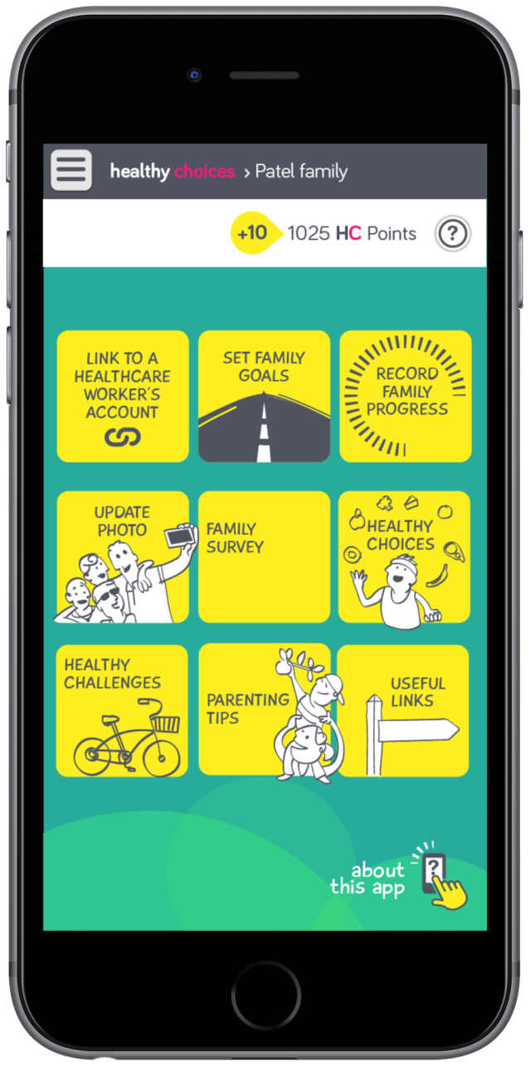

The following guidelines will need to be adhered to in creating a name for the App:

- The names of both Apps need to connect in some away to show that both apps are part of the same programme. (i.e. the current ‘holding names are’ for both Apps are Healthy Choices – Professional; Healthy Choices - Family)
- The name need to reflect the purpose of the Apps (i.e. reduce/prevent obesity).
- The maximum permitted length of the name is 28 characters (including spaces) per app, but shorter is better. If you think of a longer name, please provide appropriate abbreviation.
- Provide notes next to each name justifying or clarifying your proposed name for the Apps.
- You must check that there is no App on any of the App stores with your name suggestions.

Submit your App Name

School Name

Head Teacher Name

School Contact

App | What’s your chosen name? | What are your reasons for choosing this name?
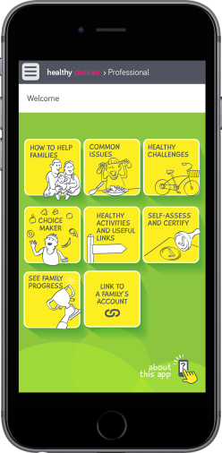 | Please write the name for the Professionals App below
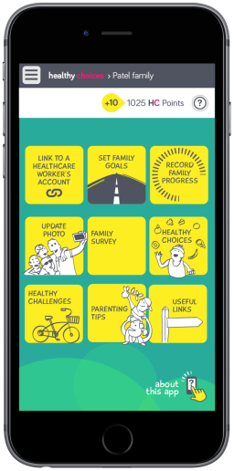 | Please write the name for the Families App below

Please submit this document to the following email address

PHNetwork.WX@hee.nhs.uk

by midnight Friday 31st March 2017

Collaboration includes University of Southampton, University of Bournemouth, HEE TV, HEE Wessex, Portsmouth Hospitals NHS Trust, Milton Cross Secondary School, Cumbria Medical Chambers, Safeguarding Lead, Dental Public Health Lead and Health and Wellbeing Lead

